**BUSINESS MODEL CANVAS**

**REPORT**

**ON**

**De-Stress service application**

*Submitted by*

**Muthalif Arshad (160410116007)**

**Daruwala Mahammadtaaha (160410116023)**

**Gulani Simran (160410116038)**

**Wade Kaustubh (160410116050)**

***In partial fulfilment***

***Of***

**BACHELOR OF ENGINEERING**

***in***

**INFORMATION TECHNLOGY**



**SARDAR VALLABHBHAI PATEL INSTITUTE OF TECHNOLOGY,**

**VASAD**

**Gujarat Technological University, Ahmedabad**

**Business Model Canvas**

The Business Model Canvas is used to validate the market significance of products and services, taken up for the project in this case. Technology projects are often solutions or processes that solve a technical problem. However, the implementation for the market of such solutions also requires that the problem solution is designed

* Not only to overcome not just the technical barriers
* But also to market-and-business related barriers of costs, customer-reach and collaborations

Thus a business model canvas can be used to visualise market problems and customer expectations. This exercise will increase the market potential and penetration of technology goods and services. This will make them more effective in market.

This exercise will bring discussions on viability and cost effectiveness into picture along with their clear impact. This exercise will enable students to have a clear understanding on the steps required to ensure that whatever solution they develop as their project should have a user who can afford it with desired needs. This exercise also helps students to understand the true value of the proposed solution.

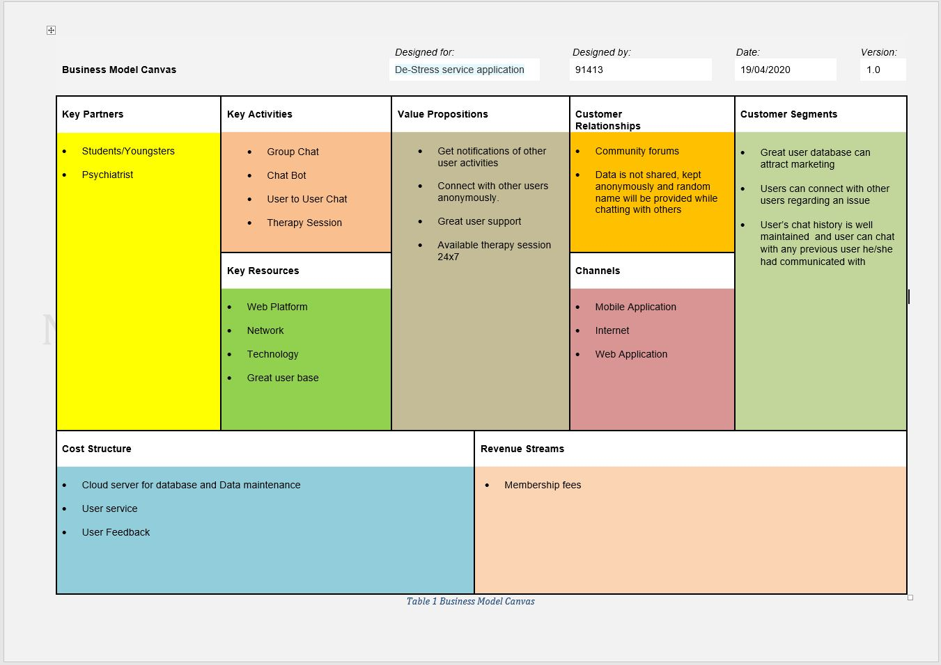

Fig: 1 Business Model Canvas

**Key Partners:**

* Students/Youngsters
* Psychiatrist

**Key Activities:**

* Group Chat
* Chat Bot
* User to User Chat
* Therapy Session

**Key Resources:**

* Web Platform
* Network
* Technology
* Great user base

**Value Propositions:**

* Get notifications of other user activities
* Connect with other users anonymously.
* Great user support
* Available therapy session 24x7

**Customer Relationship:**

* Community forums
* Data is not shared, kept anonymously and random name will be provided while chatting with others

**Channels:**

* Mobile Application
* Internet
* Web Application

**Customer segments:**

* Great user database can attract marketing
* Users can connect with other users regarding an issue
* User’s chat history is well maintained and user can chat with any previous user he/she had communicated with

**Cost Structure:**

* Cloud server for database and Data maintenance
* User service
* User Feedback

**Revenue Streams:**

* Membership fees